
OPERATIONAL EXCELLENCE | STEP 3 OF THE STORE OPTIMIZATION PROJECT
Step 3 — FSN Inventory Analysis
& Inventory Rationalization
Extrusion Stores · Factory 1 Spares · Powder Stores
Fast–Slow–Non-moving analysis of six-month store consumption, with the stock-control formulas used
Project | Store Optimization
Organization / Facility | Cosmos Air Distribution Products
Prepared by | Mahir Valani
Date | 23/05/2026
Document version | v0.1 — First draft for review
Source workbooks | 4 Excel workbooks (Extrusion, Spares, Powder,Others)

Table of Contents
1. Executive Summary 3
2. Project Context and Scope 4
2.1 Objective 4
2.2 Work carried out 4
2.3 Scope of this report 4
3. Data Sources and Method 4
3.1 Workbooks reviewed 4
3.2 How the review was done 5
3.3 FSN class labels used 5
4. FSN Classification Framework 6
5. Extrusion Stores 6
5.1 FSN summary 6
5.2 Checks and derived measures 7
5.3 Recommendations stated in the workbook 7
6. Factory 1 Spares 8
6.1 FSN summary — 549 SKUs 8
6.2 Fast-moving (A) spares 9
6.3 Demand variability 10
6.4 Non-moving stock 11
6.5 Classification and criticality 12
7. Powder Stores 13
7.1 FSN summary — 56 shades 13
7.2 Monthly pattern 14
7.3 Shade rationalization evidence 14
7.4 Fast and Medium shades — safety stock and ROP 15
8. Safety Stock and Minimum Stock Formulas 16
8.1 Formulas as built in the workbooks 16
8.2 Safety stock 16
8.3 Minimum stock level and reorder point 16
8.4 Worked examples 17
8.5 Observations on the formulas 17
8.6 Buffer policies differ between stores 18
9. Cross-Workbook Comparison 19
10. Audit Findings Register 19
11. Operational Implications and Recommendations 21
11.1 Link to the next workstreams 21
12. Validation and Next Steps 21
12.1 Information pending confirmation 22
Appendix A: Spares Register (51 SKUs) 23
Appendix B: Powder Shades (56) 25
Appendix C: Formula Audit Trail 27

Headings use Word heading styles. Page numbers shown here are static — refresh them manually after editing, or insert an automatic table of contents via References › Table of Contents.

1. Executive Summary
This report analyses three Excel workbooks prepared for the Store Optimization Project — Extrusion Stores, Factory 1 Spares and Powder Stores — each built from six months of store consumption data. The analysis is an FSN (Fast, Slow, Non-moving) analysis: items are ranked by consumption and grouped by cumulative share, so that fast-moving items can be prioritised for accessibility and control and non-moving items can be reviewed for rationalization.
Terminology — FSN, not ABC
The workbooks still use the label “ABC” in sheet names, column headers and text (for example “ABC Cat”, “ABC Dashboard”). The project owner has confirmed the analysis is FSN, so this report uses FSN throughout. The workbooks’ class codes are kept in brackets for traceability: Fast / High-moving (A), Medium-moving (B), Slow (C) and Non-moving (NM).

What the data shows
- Consumption is highly concentrated. The Fast (A) class holds 12 of 118 Extrusion families (10.2%) for 68.3% of consumption; 19 of 549 Spares SKUs (3.5%) for about 69.3% of active consumption; and 3 of 56 Powder shades (5.4%) for 75.7% of consumption (recomputed from the raw data; the workbook states 76.2%).
- Non-moving stock is large. 169 of 549 Spares SKUs (30.8%) and 25 of 56 Powder shades (44.6%) recorded zero consumption in six months. The Extrusion dashboard has no Non-moving class.
- Slow items are often occasional. In Powder, 13 of the 20 Slow (C) shades were consumed in only one of the six months.
- Stock-control formulas are simple, fixed-day rules. Safety stock = average daily consumption × 10 days (Spares) or × 3 days (Powder); reorder point (ROP) = average daily consumption × 30 days (Spares) or × 13 days (Powder). The Extrusion dashboard states a safety stock of 1.5 × average monthly consumption for Medium (B) items. Section 8 explains each formula with worked examples.

Points that need attention before the numbers are relied on
- The Extrusion workbook is a typed dashboard with no item-level register, so its classification cannot be reproduced.
- The Spares register holds 51 of the 549 SKUs; summary figures for the full range cannot be re-derived from it.
- The Spares executive summary shows ROP values at 15 days of consumption for the Fast items, while the register and the ROP section use 30 days.
- The Powder executive summary and raw data disagree for RAL 9016 MATT (month 2: 825 vs 1,365), changing the total by 540 units.
- The ROP and safety-stock formulas hard-code the day multipliers instead of reading the Lead Time and Safety Days columns, and Powder rounds daily consumption to whole numbers before multiplying.
All findings are listed in the audit register (Section 10). No saving, cost or accuracy figure is claimed in this report; the benefits stated in the workbooks that are not supported by data are flagged rather than repeated.

Recommended direction
Prioritise the Fast-moving items for accessible, controlled storage (the workbooks recommend Kanban and FIFO zones); keep ROP monitoring for Fast and Medium items; move Slow items to order-on-demand; and start a structured review of Non-moving stock. Correct the data and formula issues in Section 10 first so that the later workstreams — rack designing, binning, labeling, FIFO, kitting and Kanban — build on reliable parameters.

2. Project Context and Scope

2.1 Objective
The practical objective was to prioritise fast-moving items using six months of store consumption data, support better material accessibility and inventory control, and provide a fact-based foundation for the next Store Optimization activities.

2.2 Work carried out
- Collected historical consumption data from the Stores.
- Cleaned the dataset by removing unwanted fields.
- Performed the FSN classification using the methodology and formulas in the workbooks.
- Identified high-consumption items for priority attention.
- Reviewed consumption patterns, category distributions and the related inventory-control calculations where available.
- Developed recommendations to support the subsequent workstreams.

2.3 Scope of this report
Dimension | In scope | Not in scope / not claimed
Data | Three supplied workbooks and their formulas | Stock-on-hand, item cost, supplier lead-time records or machine-dependency data (not supplied)
Analysis | FSN classification, consumption patterns, ROP and safety-stock formulas, non-moving stock | Financial value of stock, carrying cost, savings
Outputs | Findings, audit of figures and formulas, recommendations | Implementation results
Table 1 — Scope of the FSN analysis report

3. Data Sources and Method

3.1 Workbooks reviewed
Workbook | Sheets | What it contains | Limitations observed
Extrusion Stores | ABC Dashboard (1 sheet, 1 chart) | 118 material families summarised into classes: counts, % of items, average monthly consumption (pcs), % and cumulative % of consumption, status and recommendations | No item-level register; all figures are typed text, no formulas
Factory 1 Spares | Executive Summary; Charts & Analysis (3 charts); Spares Register | 549 SKUs described; register of 51 SKUs with six monthly values, totals, averages, safety stock, ROP, category and criticality | Register covers 51 of 549 SKUs; summary tables are typed values
Powder Stores | Executive Summary; Charts & Analysis (2 charts); Powder Raw Data | 56 powder shades with six monthly values, totals, averages, share, category, daily average, safety stock and ROP | Contribution % partly filled and Cumulative % not calculated; summary tables are typed values
Table 2 — Workbooks reviewed

3.2 How the review was done
The workbooks were treated as the source of truth. Cell formulas were read directly; totals, averages, shares, cumulative percentages, class assignments, safety stock and ROP were recomputed from the monthly values and compared with the workbook figures. Where a figure could not be reproduced, or two figures conflicted, it is flagged in Section 10 and neither is silently replaced. Recomputed values shown in this report are labelled as such.

3.3 FSN class labels used
Class (this report) | Workbook code | How the workbooks describe it
Fast | A | Extrusion: High Moving; Spares: Critical; Powder: High Moving / high priority
Medium | B | Extrusion: Medium Moving; Spares: Semi-Critical; Powder: Medium Moving
Slow | C | Extrusion: Slow Moving; Spares: Non-Critical (order on demand); Powder: Low Moving (order on demand)
Non-moving | NM | Spares and Powder: zero consumption in six months; not shown separately in Extrusion
Table 3 — FSN class labels and workbook codes
FSN is conventionally three classes; the workbooks use an additional Medium band. This report keeps the workbooks’ four bands rather than merging them.

4. FSN Classification Framework
In all three workbooks items are ranked by consumption and grouped by cumulative share of consumption. The thresholds differ between workbooks.
Workbook | Fast (A) | Medium (B) | Slow (C) | Non-moving (NM)
Extrusion | Cumulative 68.3% (threshold not stated) | To 90.0% | To 100% | Not shown
Spares | Cumulative 0–70% | 70–90% | 90–100% | Zero consumption
Powder | Top 80% | Next 15% (to 95%) | Remaining 5% | Zero consumption
Table 4 — Class thresholds stated or implied in the workbooks
Reproduction test
Powder: recomputing cumulative shares from the raw data reproduces the class assignment when a shade is placed in a class only if its cumulative share stays within the threshold (Fast 75.7% after 3 shades; Medium 94.6% after 11; Slow to 100%). Spares: the 19 Fast SKUs are consistent with the stated 70% limit (69.3% of active consumption) but cannot be re-derived from the 51-SKU register. Extrusion: only the arithmetic of the summary can be checked.
The Spares summary describes the method as “Pareto 80-20” although its thresholds are 70/90/100; this is flagged in Section 10.

5. Extrusion Stores

5.1 FSN summary
Class | Material families | % of families | Avg monthly consumption (pcs) | % of consumption | Cumulative %
Fast / High (A) | 12 | 10.2% | 63,035 | 68.3% | 68.3%
Medium (B) | 19 | 16.1% | 20,028 | 21.7% | 90.0%
Slow (C) | 87 | 73.7% | 9,289 | 10.1% | 100.0%
Total | 118 | 100.0% | 92,352 | 100.0% | —
Table 5 — Extrusion FSN summary (as stated in the dashboard)
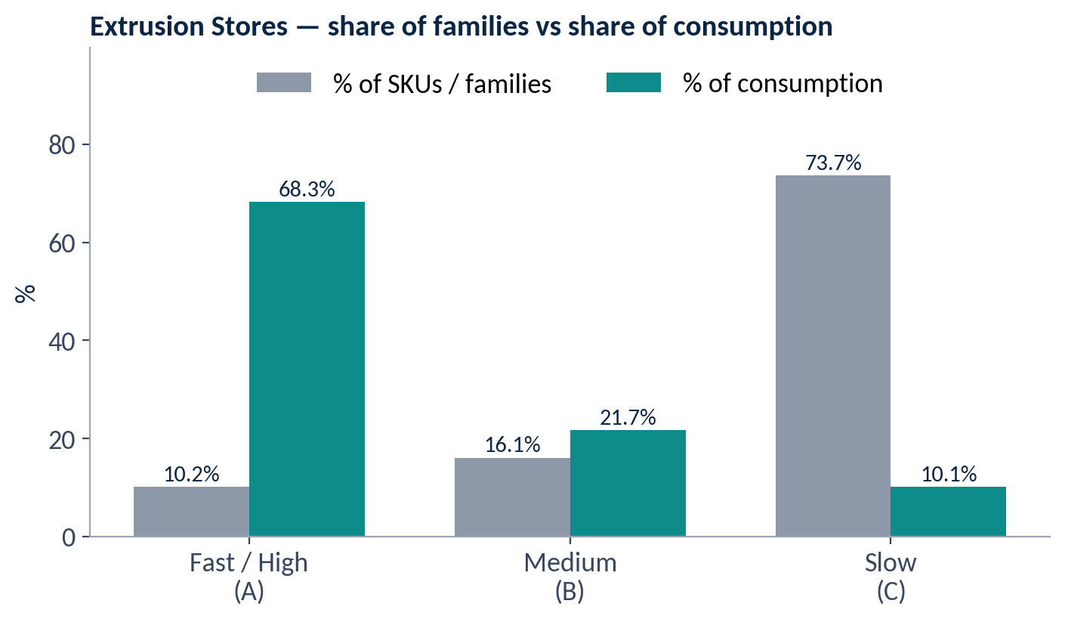
Figure 1 — Extrusion — share of families vs share of consumption

5.2 Checks and derived measures
The dashboard’s arithmetic is internally consistent: the family counts sum to 118, the consumption figures sum to 92,352 pcs per month, and the percentages and cumulative percentages follow from them. Because the dashboard holds no item-level data, the assignment of individual families to classes cannot be verified.
Class | Avg monthly pcs per family (derived) | Relative to Slow family | Basis
Fast (A) | ≈ 5,253 | ≈ 49× | 63,035 ÷ 12
Medium (B) | ≈ 1,054 | ≈ 10× | 20,028 ÷ 19
Slow (C) | ≈ 107 | 1× | 9,289 ÷ 87
Table 6 — Average consumption per family — derived by this report (class averages, not item data)

5.3 Recommendations stated in the workbook
- Fast (A): Kanban card-controlled shelf zones with Min–Max visual stock markers and strict FIFO bin arrangement (Min and Max values are not given).
- Medium (B): bi-weekly review; maintain safety stock of 1.5 × average monthly consumption.
- Slow (C): quarterly demand review; reclassify quarterly; consider supplier-managed or consignment stock to reduce dead stock holding.
FIFO and Kanban are recommended here as storage and replenishment practices; they are separate workstreams and are not features of the ERP.

6. Factory 1 Spares

6.1 FSN summary — 549 SKUs
Class | SKUs | % of SKUs | Share of active consumption | Criticality label in workbook
Fast (A) | 19 | 3.5% | ≈ 69.3% | Critical
Medium (B) | 31 | 5.6% | ≈ 20.6% | Semi-Critical
Slow (C) | 329 | 59.9% | ≈ 10.1% | Non-Critical
Non-moving (NM) | 169 | 30.8% | 0% (zero in six months) | Dead / Obsolete
Table 7 — Spares FSN summary (workbook figures; % of SKUs computed by this report)
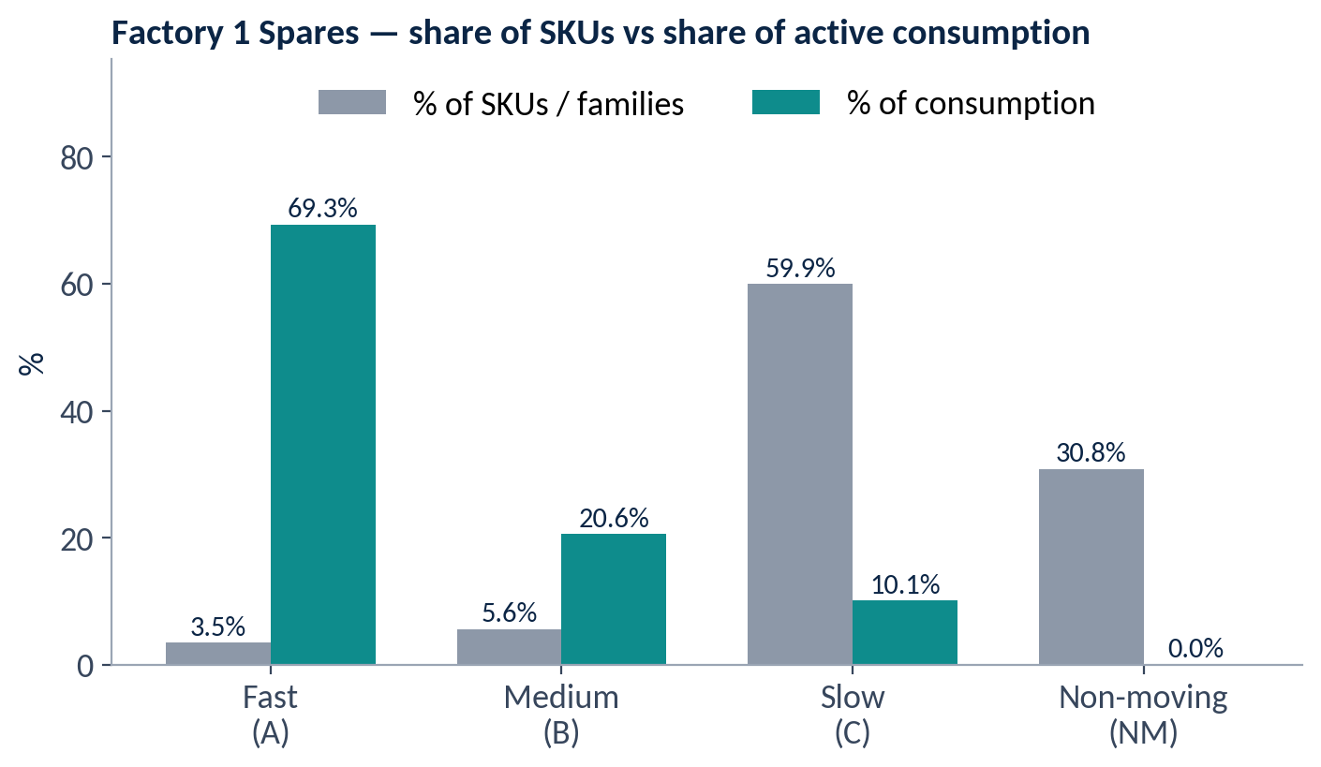
Figure 2 — Spares — share of SKUs vs share of active consumption
The register supplied holds 51 SKUs (19 Fast, 12 Medium, 10 Slow, 10 Non-moving) and totals 4,651,455 units over six months. The 19 Fast SKUs in the register match the 19 stated in the summary, and their combined six-month consumption is 3,898,794 units (649,800 per month), which agrees with the summary table.

6.2 Fast-moving (A) spares
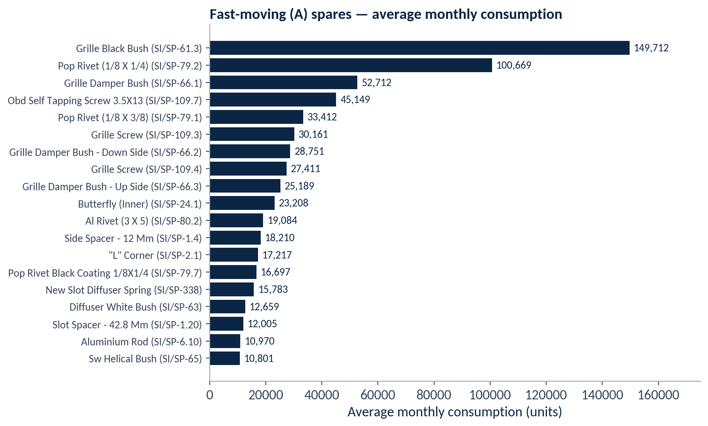
Figure 3 — Fast-moving spares — average monthly consumption
The two highest items, Grille Black Bush and Pop Rivet (1/8 × 1/4), average 149,712 and 100,669 units per month — together 38.5% of the 649,800 monthly units of the Fast class. These items are the logical first candidates for accessible, controlled storage.
Spare | Code | Avg monthly | Total (6M) | Avg daily | Safety stock | ROP | Peak ÷ avg month
GRILLE BLACK BUSH | SI/SP-61.3 | 149,712 | 898,274 | 4,990 | 49,900 | 149,700 | 1.87×
POP RIVET (1/8 x 1/4) | SI/SP-79.2 | 100,669 | 604,016 | 3,356 | 33,560 | 100,680 | 1.48×
GRILLE DAMPER BUSH | SI/SP-66.1 | 52,712 | 316,270 | 1,757 | 17,570 | 52,710 | 1.43×
OBD SELF TAPPING SCREW 3.5X13 | SI/SP-109.7 | 45,149 | 270,892 | 1,505 | 15,050 | 45,150 | 1.33×
POP RIVET (1/8 x 3/8) | SI/SP-79.1 | 33,412 | 200,472 | 1,114 | 11,140 | 33,420 | 1.26×
GRILLE SCREW | SI/SP-109.3 | 30,161 | 180,967 | 1,005 | 10,050 | 30,150 | 1.52×
GRILLE DAMPER BUSH - DOWN SIDE | SI/SP-66.2 | 28,751 | 172,508 | 958 | 9,580 | 28,740 | 1.39×
GRILLE SCREW | SI/SP-109.4 | 27,411 | 164,465 | 914 | 9,140 | 27,420 | 1.67×
GRILLE DAMPER BUSH - UP SIDE | SI/SP-66.3 | 25,189 | 151,133 | 840 | 8,400 | 25,200 | 1.42×
BUTTERFLY (INNER) | SI/SP-24.1 | 23,208 | 139,247 | 774 | 7,740 | 23,220 | 1.34×
AL RIVET (3 x 5) | SI/SP-80.2 | 19,084 | 114,504 | 636 | 6,360 | 19,080 | 1.81×
SIDE SPACER - 12 mm | SI/SP-1.4 | 18,210 | 109,258 | 607 | 6,070 | 18,210 | 1.61×
"L" CORNER | SI/SP-2.1 | 17,217 | 103,300 | 574 | 5,740 | 17,220 | 1.37×
POP RIVET BLACK COATING 1/8x1/4 | SI/SP-79.7 | 16,697 | 100,180 | 557 | 5,570 | 16,710 | 1.54×
NEW SLOT DIFFUSER SPRING | SI/SP-338 | 15,783 | 94,695 | 526 | 5,260 | 15,780 | 1.35×
DIFFUSER WHITE BUSH | SI/SP-63 | 12,659 | 75,955 | 422 | 4,220 | 12,660 | 1.49×
SLOT SPACER - 42.8 mm | SI/SP-1.20 | 12,005 | 72,032 | 400 | 4,000 | 12,000 | 1.75×
ALUMINIUM ROD | SI/SP-6.10 | 10,970 | 65,820 | 366 | 3,660 | 10,980 | 1.45×
SW HELICAL BUSH | SI/SP-65 | 10,801 | 64,806 | 360 | 3,600 | 10,800 | 2.74×
Table 8 — Fast-moving spares in the register — consumption, safety stock and ROP (register values; last column derived)

6.3 Demand variability
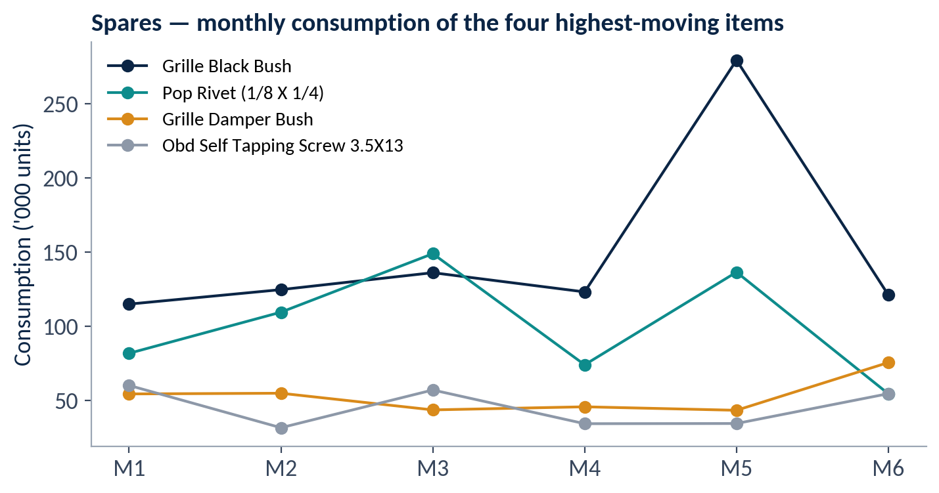
Figure 4 — Monthly consumption of the four highest-moving spares
Monthly consumption is not flat. Grille Black Bush peaked at 279,257 units in month 5 against a six-month average of 149,712 (1.87×). Across the 19 Fast spares, the peak month is between 1.26× and 2.74× the average; SW Helical Bush is the most variable (2.74×). The workbooks’ safety stock is a fixed number of days and does not use these fluctuations; this is a point to validate (Section 8.5).
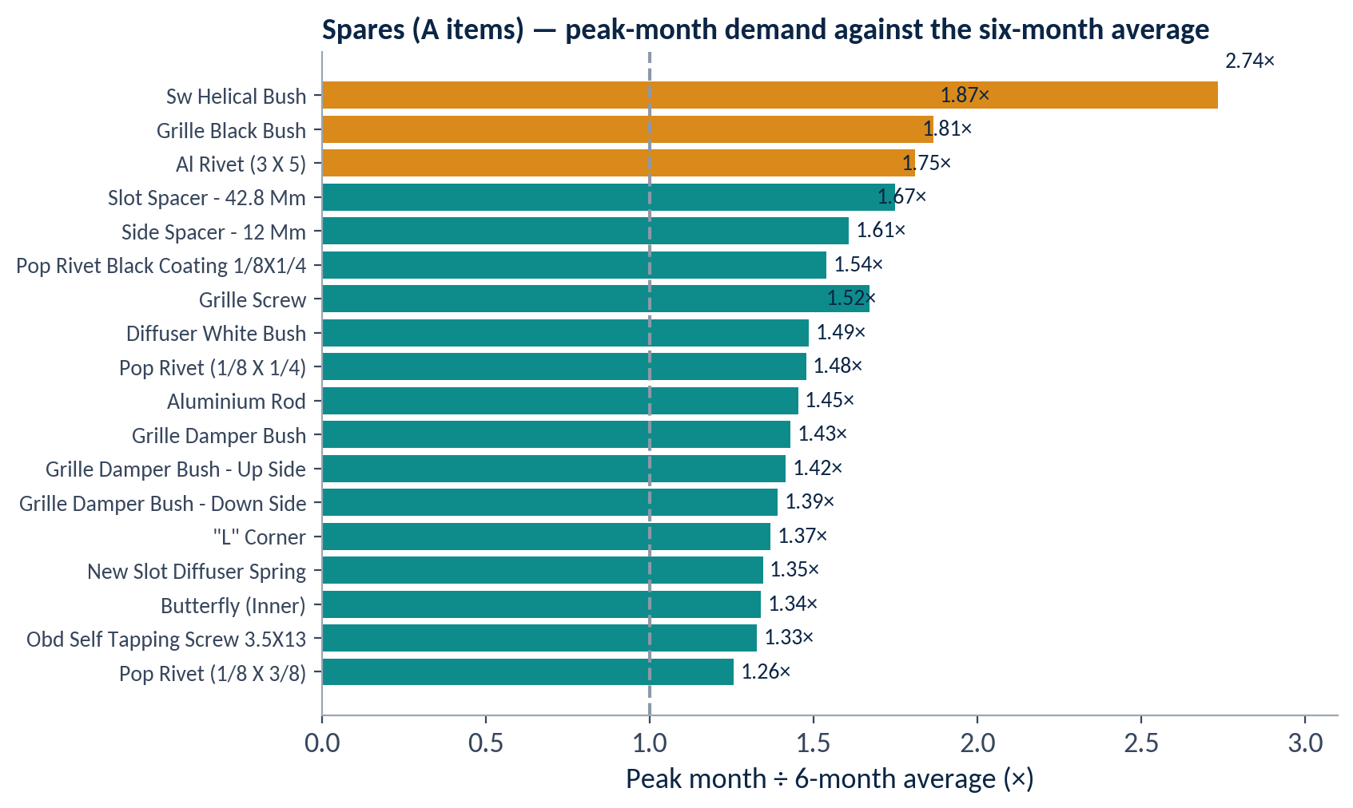
Figure 5 — Peak-month consumption ÷ six-month average (derived by this report)

6.4 Non-moving stock
169 SKUs (30.8% of all spares) recorded zero consumption over six months. The workbook classifies them as Dead / Obsolete and recommends review and write-off. The breakdown by spare family is below.
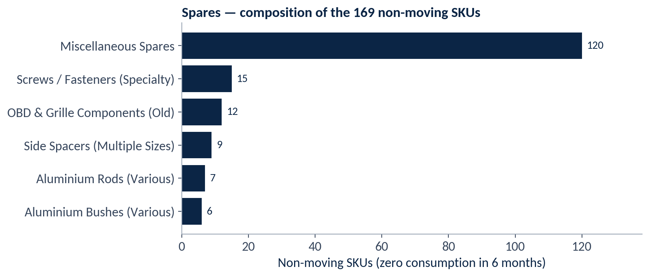
Figure 6 — Composition of the non-moving spares
Non-moving family | SKUs | Recommended action in the workbook
Side Spacers (multiple sizes) | 9 | Consolidate or substitute with active sizes; review the engineering BOM
Aluminium Rods (various) | 7 | Evaluate common-size substitution; return excess to vendor if possible
Aluminium Bushes (various) | 6 | Assess machine dependency; write off if the machine is retired
OBD & Grille Components (old) | 12 | Check design change history (may be superseded); quarantine and review
Screws / Fasteners (specialty) | 15 | Validate against current product BOM; dispose of obsolete fasteners
Miscellaneous Spares | 120 | Quarterly physical audit; tag and isolate for write-off assessment
Table 9 — Non-moving spares and workbook recommendations (the six families sum to 169)

6.5 Classification and criticality
The criticality label in the workbook follows directly from the movement class (Fast → Critical, Medium → Semi-Critical, Slow → Non-Critical, Non-moving → Dead / Obsolete). It is therefore a consumption-based label, not an assessment of machine dependency; the workbook itself recommends classifying each spare against machine dependency before procurement approval. A low-consumption item can still be critical if its absence stops a machine, which the current classification would not show.

7. Powder Stores

7.1 FSN summary — 56 shades
Class | Shades | Total consumption (6M, recomputed) | Share (recomputed) | Share in workbook | Cumulative (recomputed)
Fast (A) | 3 | 14,672 | 75.7% | 76.2% | 75.7%
Medium (B) | 8 | 3,657 | 18.9% | 18.9% | 94.6%
Slow (C) | 20 | 1,055 | 5.4% | 4.9% | 100.0%
Non-moving (NM) | 25 | 0 | 0% | 0% | —
Total | 56 | 19,384 | 100% | — | —
Table 10 — Powder FSN summary — recomputed from the Powder Raw Data sheet
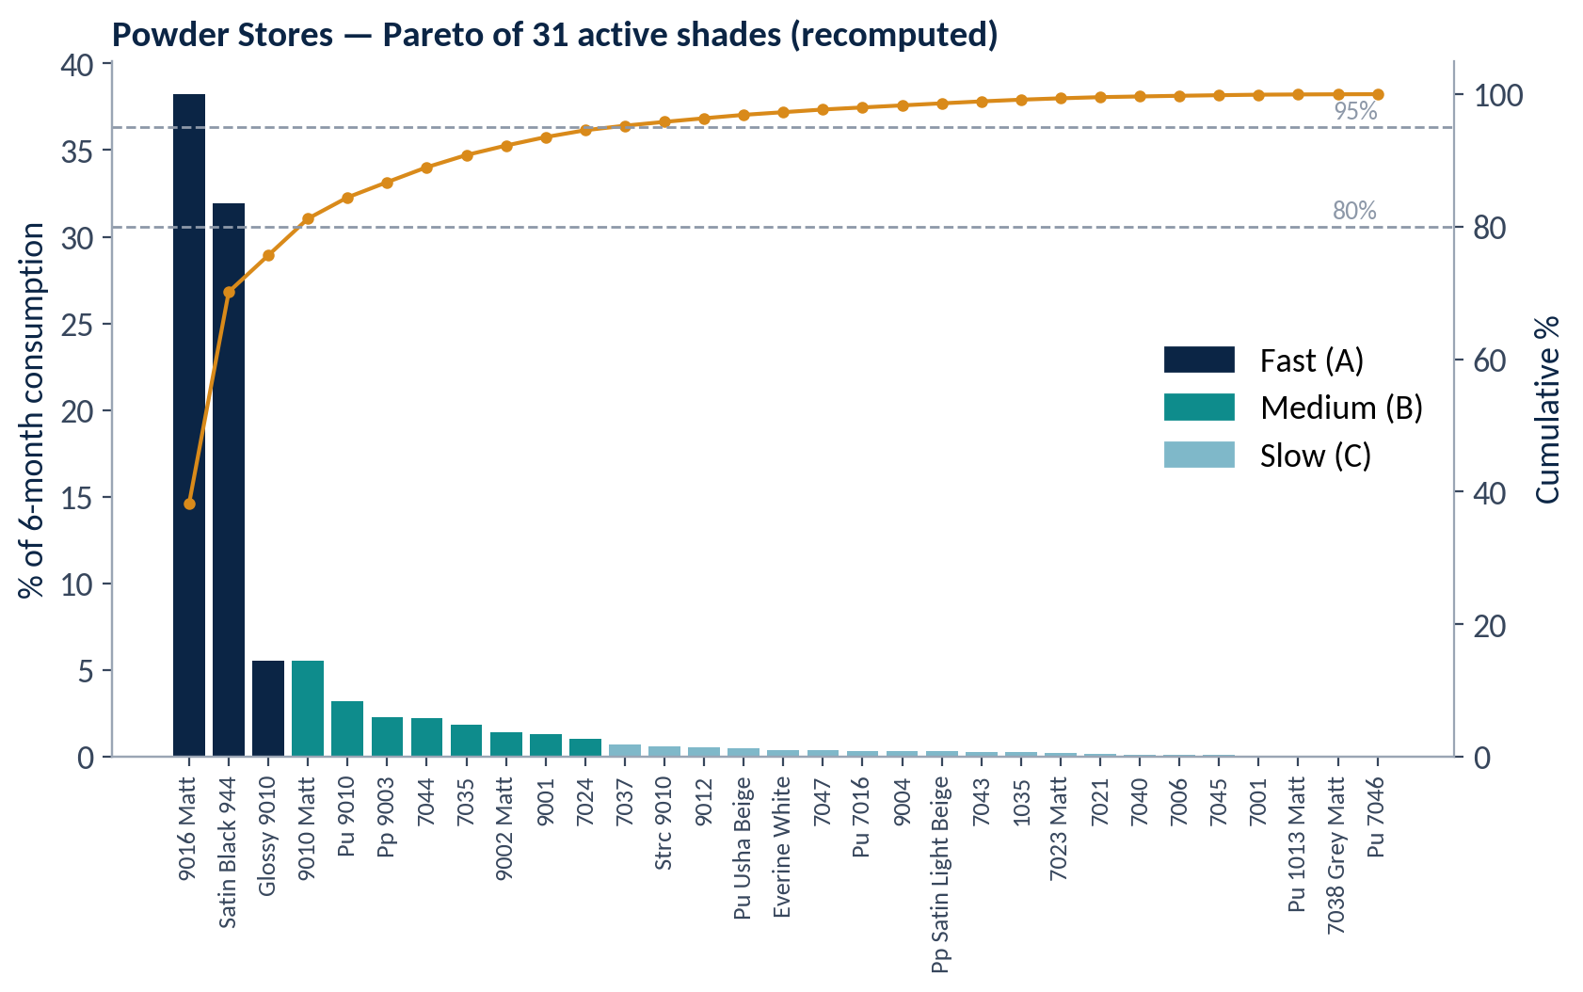
Figure 7 — Powder — Pareto of the 31 shades with consumption (recomputed cumulative share)
RAL 9016 MATT (38.2%) and Satin Black (31.9%) alone account for 70.2% of consumption. RAL Glossy 9010 takes the Fast class to 75.7%. The next shade, RAL 9010 Matt, has identical six-month consumption (1,072) but is classed Medium; the workbook gives no tie-break rule (Section 10).
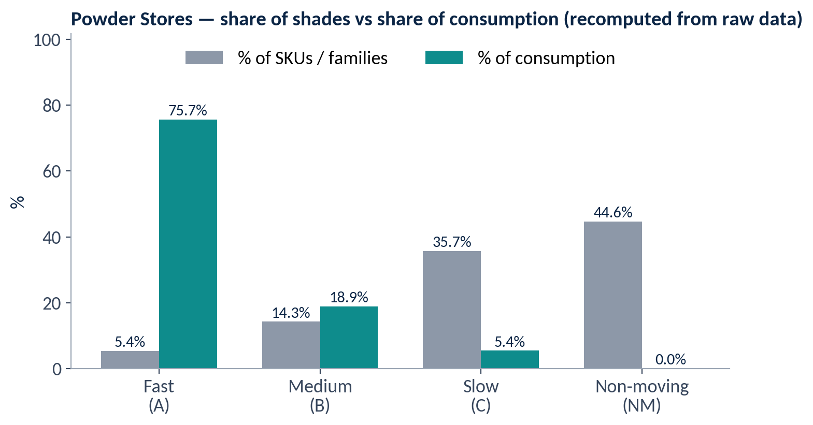
Figure 8 — Powder — share of shades vs share of consumption

7.2 Monthly pattern
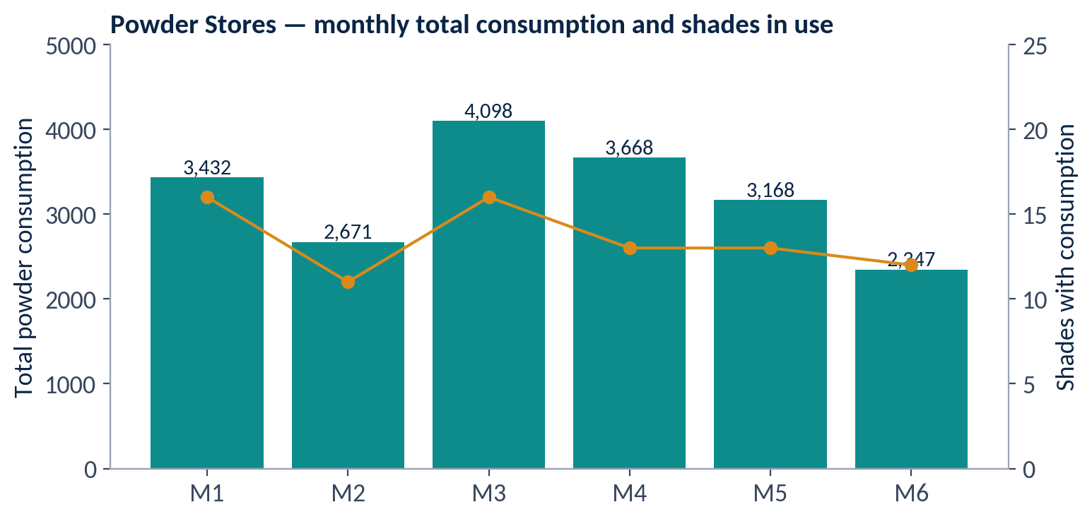
Figure 9 — Powder — total monthly consumption and number of shades in use
Total powder consumption ranged from 2,347 (month 6) to 4,098 (month 3). Between 11 and 16 shades were consumed in any single month, out of 31 shades with any consumption. The three Fast shades were consumed in 4 to 6 of the six months; Slow shades were mostly occasional — 13 of the 20 were consumed in just one month.

7.3 Shade rationalization evidence
The workbook proposes cutting the shade count by about 30–40% through standardization. The data supports reviewing the following groups; whether shades can be merged depends on finish, chemistry and customer specification, which the workbooks do not record.
Group | Shades | Six-month consumption | Observation
RAL 9010 variants (Glossy, Matt, PU, STRC) | 4 | 2,877 (14.8%) | Four shades with consumption: one Fast, two Medium and one Slow
RAL 70xx greys | 15 active, 11 non-moving | 1,476 (7.6%) | Many shades share a small fraction of total consumption
Non-moving shades | 25 | 0 | No consumption in six months; candidates for return, write-off or substitution
Table 11 — Shade groups for rationalization review (derived by this report from the raw data)

7.4 Fast and Medium shades — safety stock and ROP
Shade | Avg monthly | Avg daily | Safety stock | ROP | Class | Share
Ral 9016 Matt | 1,235 | 41 | 123 | 533 | A | 38.2%
Satin Black 944 | 1,032 | 34 | 102 | 442 | A | 31.9%
Ral Glossy 9010 | 179 | 6 | 18 | 78 | A | 5.5%
Ral 9010 Matt | 179 | 6 | 18 | 78 | B | 5.5%
Pu Ral 9010 | 104 | 3 | 9 | 39 | B | 3.2%
Pp Ral 9003 | 74 | 2 | 6 | 26 | B | 2.3%
Ral 7044 | 73 | 2 | 6 | 26 | B | 2.3%
Ral 7035 | 60 | 2 | 6 | 26 | B | 1.8%
Ral 9002 Matt | 46 | 2 | 6 | 26 | B | 1.4%
Ral 9001 | 41 | 1 | 3 | 13 | B | 1.3%
Ral 7024 | 33 | 1 | 3 | 13 | B | 1.0%
Table 12 — Powder Fast and Medium shades — values from the raw-data sheet; share recomputed

8. Safety Stock and Minimum Stock Formulas
This section explains the formulas the workbooks use to set safety stock and the reorder trigger (minimum stock level), with a worked example from each workbook.

8.1 Formulas as built in the workbooks
Workbook | Quantity | Formula in the workbook | Meaning
Spares | Avg monthly (col L) | =ROUND(AVERAGE(E:J),0) | Mean of the six monthly values, rounded
Spares | Avg daily (col M) | =ROUND(L/30,0) | Avg monthly ÷ 30 days, rounded to whole units
Spares | Safety stock (col P) | =M × 10 | Avg daily × 10 days of safety buffer
Spares | ROP (col Q) | =M × 30 | Avg daily × (20 days lead time + 10 days safety)
Powder | Avg monthly (col L) | =ROUND(AVERAGE(E:J),0) | Mean of the six monthly values, rounded
Powder | Avg daily (col P) | =ROUND(L/30,0) | Avg monthly ÷ 30 days, rounded
Powder | Safety stock (col S) | =P × 3 | Avg daily × 3 days of safety buffer
Powder | ROP (col T) | =P × 13 | Avg daily × (10 days lead time + 3 days safety)
Extrusion | Safety stock (Medium class) | 1.5 × average monthly consumption (text, no formula) | Stated for B items; family-level values not supplied
Table 13 — Formulas used for safety stock and reorder point

8.2 Safety stock
Safety stock = Average daily consumption × Safety days. It is a reserve held on top of expected lead-time demand to protect against supply disruption (the Spares workbook describes it as an emergency reserve) or uncertainty (Powder). The buffer is a fixed number of days — 10 for Spares, 3 for Powder — applied equally to every item.

8.3 Minimum stock level and reorder point
Reorder point (ROP) = Average daily consumption × (Lead time + Safety days) = Lead-time demand + Safety stock. When stock reaches the ROP a purchase order is placed immediately (both workbooks). The ROP is therefore the minimum stock level in practice: the level below which stock must not be allowed to fall without an order already in progress. Within it, the safety stock is the floor that should only be consumed if the supplier is late.
Note on the term “minimum stock”
Neither workbook has a column named “Minimum Stock”, and neither defines a Maximum level. This report uses “minimum stock level” to mean the ROP, as the workbooks apply it. The Extrusion dashboard refers to “Min–Max visual stock markers” for Fast items but gives no values. If a Min–Max pair is needed for the Kanban workstream, the Max level will have to be defined; it is not available from the workbooks.

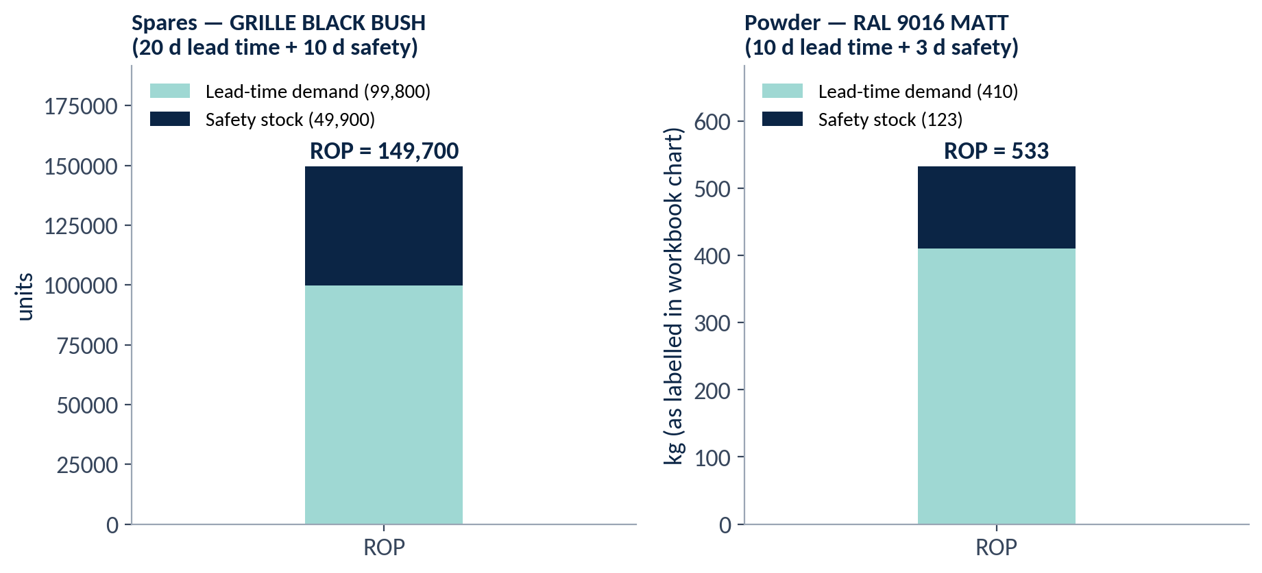
Figure 10 — Structure of the ROP — lead-time demand plus safety stock (worked examples)

8.4 Worked examples
Step | Spares — Grille Black Bush | Powder — RAL 9016 MATT
Six monthly values | 114,742; 124,501; 135,927; 122,961; 279,257; 120,886 | 1,215; 1,365; 1,605; 1,425; 1,200; 600
Total (6 months) | 898,274 | 7,410
Average monthly (÷ 6) | 149,712 | 1,235
Average daily (÷ 30) | 4,990 | 41
Lead-time demand (daily × lead days) | 4,990 × 20 = 99,800 | 41 × 10 = 410
Safety stock (daily × safety days) | 4,990 × 10 = 49,900 | 41 × 3 = 123
ROP = lead-time demand + safety stock | 99,800 + 49,900 = 149,700 (= 4,990 × 30) | 410 + 123 = 533 (= 41 × 13)
Table 14 — Step-by-step calculation of safety stock and ROP

8.5 Observations on the formulas
Fixed-day buffers do not reflect variability. A 10-day buffer equals one third of an average month. The Fast spares’ peak months run from 1.26× to 2.74× average (Section 6.3). Whether 10 days is enough depends on actual lead-time performance and stock held at the trigger; this should be validated against supplier delivery records.
Day multipliers are typed into the formulas. The Lead Time and Safety Days columns (Spares N, O; Powder Q, R) are not referenced; the formulas contain the constants 10, 30, 3 and 13. Changing an item’s lead time in its column would not change its ROP.
Rounding of daily consumption. Both workbooks round the daily average to whole units before multiplying. For Spares this is immaterial. For low-volume Powder shades it changes the result noticeably, as the table shows; for Powder shades with an average monthly consumption of 14 or less, the daily average rounds to zero and the safety stock and ROP become zero.
Powder shade | Avg monthly | Avg daily (workbook) | Avg daily (unrounded) | ROP (workbook) | ROP (unrounded) | Safety stock (workbook) | ROP difference
Ral 9016 Matt | 1,235 | 41 | 41.2 | 533 | 535.2 | 123 | -0.4%
Satin Black 944 | 1,032 | 34 | 34.4 | 442 | 447.2 | 102 | -1.2%
Ral Glossy 9010 | 179 | 6 | 6 | 78 | 77.6 | 18 | +0.6%
Ral 9010 Matt | 179 | 6 | 6 | 78 | 77.6 | 18 | +0.6%
Pu Ral 9010 | 104 | 3 | 3.5 | 39 | 45.1 | 9 | -13.5%
Pp Ral 9003 | 74 | 2 | 2.5 | 26 | 32.1 | 6 | -18.9%
Ral 7044 | 73 | 2 | 2.4 | 26 | 31.6 | 6 | -17.8%
Ral 7035 | 60 | 2 | 2 | 26 | 26 | 6 | 0%
Ral 9002 Matt | 46 | 2 | 1.5 | 26 | 19.9 | 6 | +30.4%
Ral 9001 | 41 | 1 | 1.4 | 13 | 17.8 | 3 | -26.8%
Ral 7024 | 33 | 1 | 1.1 | 13 | 14.3 | 3 | -9.1%
Table 15 — Effect of rounding on Powder ROP — unrounded values recomputed by this report for comparison only
Five of the eleven Fast and Medium shades differ by more than 10% from the unrounded ROP, in both directions (−26.8% to +30.4%). This is not a recommendation to change the formula; it shows that the rounding is an issue to resolve before ROP values are used for Kanban card sizing.

8.6 Buffer policies differ between stores
Store | Buffer in the workbook | Equivalent in days (30-day month) | Applies to
Extrusion | Safety stock = 1.5 × average monthly consumption | ≈ 45 days | Medium (B) families
Factory 1 Spares | Safety stock = 10 days of consumption | 10 days | Fast and Medium items with ROP
Powder | Safety stock = 3 days of consumption | 3 days | Fast and Medium shades with ROP
Table 16 — Safety-buffer policy by store (days equivalent derived by this report)
The three stores use different buffer logic, and the source for the chosen values (20- and 10-day lead times for Spares, 10 and 3 days for Powder) is not documented in the workbooks. These parameters should be confirmed with Purchase before they are carried into the Kanban workstream.

9. Cross-Workbook Comparison
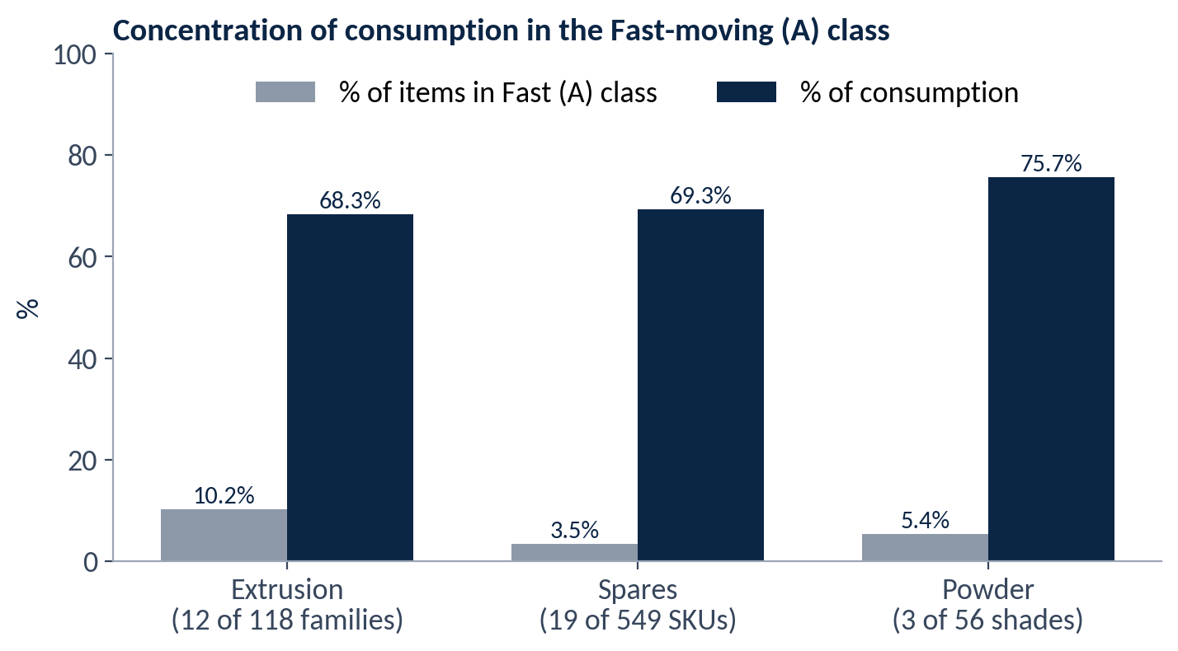
Figure 11 — Concentration of consumption in the Fast-moving class
Measure | Extrusion | Spares | Powder | Comment
Items in scope | 118 families | 549 SKUs | 56 shades | Spares register shows 51 SKUs
Fast (A) items | 12 (10.2%) | 19 (3.5%) | 3 (5.4%) | Pareto concentration in all three
Fast share of consumption | 68.3% | ≈ 69.3% | 75.7% (recomputed) | Powder workbook states 76.2%
Non-moving items | Not shown | 169 (30.8%) | 25 (44.6%) | Highest in Powder
Reorder logic | Not formula-based | ROP = daily × 30 | ROP = daily × 13 | Fixed-day rules
Safety buffer | 1.5 × avg monthly (B) | 10 days | 3 days | Different policies
Data traceability | Typed dashboard | 51 of 549 SKUs in register | Full raw data | Powder most reproducible
Table 17 — Comparison of the three workbooks

10. Audit Findings Register
The table lists inconsistencies, gaps and unsupported statements found while recomputing the workbooks. None has been corrected in the source files; the report preserves the workbook figures and states the recomputed values alongside.
ID | Workbook | Finding | Evidence | Implication | Suggested action
D-01 | All | Sheet names, column headers and text use “ABC” although the analysis is FSN | Examples: “ABC Cat”, “ABC Dashboard”, “ABC Classification Summary” | Labels inconsistent with the confirmed method | Relabel to FSN
D-02 | Extrusion | Dashboard holds typed values only; no item-level register or formulas | All KPI cells are text | Classification cannot be reproduced | Provide the family-level register
D-03 | Spares | Register has 51 of 549 SKUs | Footer: “51 representative SKUs (full dataset: 549)” | Summary shares for all 549 cannot be re-derived | Provide the full register
D-04 | Spares | ROP in the Fast-item table (Section 04) equals daily × 15; register and Section 06 use daily × 30 | e.g. Grille Black Bush: 74,850 vs 149,700 | Conflicting reorder levels for the same items | Confirm the intended multiplier
D-05 | Spares | Class counts sum to 548 (19+31+329+169) against 549 stated | Executive Summary | One SKU unaccounted for | Reconcile the count
D-06 | Spares, Powder | ROP and safety stock hard-code the day multipliers; Lead Time and Safety Days columns are not referenced | Spares =M×10, =M×30; Powder =P×3, =P×13 | Changing inputs does not update results | Link formulas to the input columns
D-07 | Powder | RAL 9016 MATT month 2: 825 (summary) vs 1,365 (raw data); total 6,870 vs 7,410 | Grand total 18,844 vs 19,384 | Totals and shares differ by 540 units | Confirm correct month-2 value
D-08 | Powder | Class shares stated 76.2 / 18.9 / 4.9%; recomputed 75.7 / 18.9 / 5.4% | Raw data totals | Stated shares not reproducible | Recalculate from the raw data
D-09 | Powder | Contribution % filled for 11 shades only; Cumulative % shows “—” | Columns M, N of raw data | Classification not traceable in the sheet | Complete both columns with formulas
D-10 | Powder | RAL Glossy 9010 and RAL 9010 Matt both total 1,072 but sit in different classes (A, B) | Ranks 3 and 4 | No stated tie-break rule | Document the rule
D-11 | Powder | Daily average rounded before multiplying | See Table 15 | ROP differs from unrounded by −26.8% to +30.4% for Fast and Medium shades | Decide on rounding approach
D-12 | Powder | Summary row “Grand total” shows 98 for Avg monthly: an average of per-row averages including the Non-moving aggregate row | Cell J53 | Value is not a total (total of averages ≈ 3,234) | Relabel or replace with a sum
D-13 | Spares, Powder | Thresholds differ (Spares 70/90/100; Powder 80/95/100); Spares text says “Pareto 80-20” | Methodology sections | Class boundaries not comparable across stores | Agree one rule or document the difference
D-14 | Powder | Shade named “Satin Black 9005” in the summary and “Satin Black 944” in the raw data | Code SI/SP-285.13 | Naming inconsistency | Confirm the correct name
D-15 | Spares, Powder | Units stated only in a Powder chart title (Kg); Spares units not stated | Charts & Analysis | Quantities may be misread | State units on all sheets
D-16 | Spares | Criticality assigned from movement class rather than machine dependency | Criticality column mirrors class | Low-consumption but machine-critical items not identified | Add a machine-dependency assessment
D-17 | Spares, Powder | Estimates in the summaries (30%+ rack space recovered; 15–20% SKU reduction; 30–40% shade reduction) are not supported by data in the workbooks | Findings sections | Unsupported figures | Treat as unvalidated hypotheses
Table 18 — Audit findings register

11. Operational Implications and Recommendations
Recommendations below are drawn from the workbooks and from this analysis. They are proposals; none has been implemented and no benefit is claimed.
Area | Recommendation | Source / link
Prioritise Fast items | Give the 12 Extrusion, 19 Spares and 3 Powder Fast items the most accessible, controlled locations with Kanban and FIFO-based replenishment | Workbook recommendations; rack designing, Kanban, FIFO workstreams
FSN-based zoning | Fast items at front / accessible rows, Medium at mid-level, Slow and Non-moving in a rear quarantine or review zone | Spares and Powder workbooks; rack designing
Reorder control | Keep ROP monitoring for Fast and Medium items; Slow items on order-on-demand | Spares and Powder workbooks
Non-moving review | Quarterly review of the 169 Spares (return to vendor / write-off / hold) and review of the 25 Powder shades; tag and isolate pending decision | Workbooks; Section 6.4
Shade standardization | Review the shade groups in Table 11 with technical and sales input before merging any | Section 7.3
Fix the numbers first | Resolve D-04, D-05, D-07 and D-09; link formulas to input cells; decide the rounding approach | Section 10
Validate buffers | Compare the fixed-day buffers with actual supplier lead times and the observed peaks before sizing Kanban cards | Section 8.5
Define Min–Max | If Min–Max is needed for Kanban, define Max levels; the workbooks give only the reorder point | Section 8.3
Add machine criticality | Classify spares against machine dependency, in addition to consumption | D-16; workbook recommendation 06
Table 19 — Recommendations

11.1 Link to the next workstreams
Workstream | What this analysis provides
Rack designing | Fast / Slow / Non-moving lists for zoning; volume of Fast items
Binning and labeling | Item lists with codes; Fast items first
FIFO | Identification of items where rotation matters — FIFO is a physical storage and issuing method, not an ERP function
Kitting | Fast items consumed together (to be identified with Production)
Kanban | ROP and safety-stock starting values, subject to the validations above
Table 20 — Inputs to the subsequent workstreams

12. Validation and Next Steps
- Provide the item-level Extrusion register and the full 549-SKU Spares register.
- Resolve the audit findings D-04, D-05 and D-07 with the workbook owners.
- Confirm lead-time and safety-day values with Purchase and the Stores.
- Decide on the rounding and day-basis (30 days) for daily consumption.
- Link the ROP and safety-stock formulas to the input columns.
- Agree one set of FSN thresholds, or document why they differ.
- Carry the validated Fast / Slow / Non-moving lists into the rack designing, binning, labeling, FIFO, kitting and Kanban workstreams.

Appendix A: Spares Register (51 SKUs)
Values as in the Spares Register sheet, ordered by six-month consumption. Safety stock and ROP follow the workbook formulas (daily × 10 and daily × 30).
Sr | Code | Spare | Total (6M) | Avg monthly | Avg daily | Safety stock | ROP | Class
187 | SI/SP-61.3 | GRILLE BLACK BUSH | 898,274 | 149,712 | 4,990 | 49,900 | 149,700 | A
195 | SI/SP-79.2 | POP RIVET (1/8 x 1/4) | 604,016 | 100,669 | 3,356 | 33,560 | 100,680 | A
424 | SI/SP-66.1 | GRILLE DAMPER BUSH | 316,270 | 52,712 | 1,757 | 17,570 | 52,710 | A
415 | SI/SP-109.7 | OBD SELF TAPPING SCREW 3.5X13 | 270,892 | 45,149 | 1,505 | 15,050 | 45,150 | A
194 | SI/SP-79.1 | POP RIVET (1/8 x 3/8) | 200,472 | 33,412 | 1,114 | 11,140 | 33,420 | A
250 | SI/SP-109.3 | GRILLE SCREW | 180,967 | 30,161 | 1,005 | 10,050 | 30,150 | A
425 | SI/SP-66.2 | GRILLE DAMPER BUSH - DOWN SIDE | 172,508 | 28,751 | 958 | 9,580 | 28,740 | A
251 | SI/SP-109.4 | GRILLE SCREW | 164,465 | 27,411 | 914 | 9,140 | 27,420 | A
426 | SI/SP-66.3 | GRILLE DAMPER BUSH - UP SIDE | 151,133 | 25,189 | 840 | 8,400 | 25,200 | A
159 | SI/SP-24.1 | BUTTERFLY (INNER) | 139,247 | 23,208 | 774 | 7,740 | 23,220 | A
197 | SI/SP-80.2 | AL RIVET (3 x 5) | 114,504 | 19,084 | 636 | 6,360 | 19,080 | A
8 | SI/SP-1.4 | SIDE SPACER - 12 mm | 109,258 | 18,210 | 607 | 6,070 | 18,210 | A
23 | SI/SP-2.1 | "L" CORNER | 103,300 | 17,217 | 574 | 5,740 | 17,220 | A
423 | SI/SP-79.7 | POP RIVET BLACK COATING 1/8x1/4 | 100,180 | 16,697 | 557 | 5,570 | 16,710 | A
422 | SI/SP-338 | NEW SLOT DIFFUSER SPRING | 94,695 | 15,783 | 526 | 5,260 | 15,780 | A
189 | SI/SP-63 | DIFFUSER WHITE BUSH | 75,955 | 12,659 | 422 | 4,220 | 12,660 | A
421 | SI/SP-1.20 | SLOT SPACER - 42.8 mm | 72,032 | 12,005 | 400 | 4,000 | 12,000 | A
53 | SI/SP-6.10 | ALUMINIUM ROD | 65,820 | 10,970 | 366 | 3,660 | 10,980 | A
190 | SI/SP-65 | SW HELICAL BUSH | 64,806 | 10,801 | 360 | 3,600 | 10,800 | A
175 | SI/SP-45 | LIVER GUN | 63,710 | 10,618 | 354 | 3,540 | 10,620 | B
119 | SI/SP-13.2 | DIFFUSER SPRING | 61,751 | 10,292 | 343 | 3,430 | 10,290 | B
10 | SI/SP-1.6 | SIDE SPACER - 16 mm | 56,287 | 9,381 | 313 | 3,130 | 9,390 | B
6 | SI/SP-1.2 | SIDE SPACER - 9 mm | 55,248 | 9,208 | 307 | 3,070 | 9,210 | B
269 | SI/SP-121 | S.S. CORNER-90° | 54,709 | 9,118 | 304 | 3,040 | 9,120 | B
160 | SI/SP-24.2 | BUTTERFLY (OUTER) | 54,078 | 9,013 | 300 | 3,000 | 9,000 | B
47 | SI/SP-6.4 | ALUMINIUM ROD | 50,759 | 8,460 | 282 | 2,820 | 8,460 | B
357 | SI/CP-11.1 | SQ INN - 150 | 48,610 | 8,102 | 270 | 2,700 | 8,100 | B
358 | SI/CP-11.2 | SQ INN - 225 | 48,458 | 8,076 | 269 | 2,690 | 8,070 | B
292 | SI/SP-236 | PRODUCT STICKER | 48,457 | 8,076 | 269 | 2,690 | 8,070 | B
439 | SI/SP-109.20 | OBD ROD SCREW 4.3X12 | 48,158 | 8,026 | 268 | 2,680 | 8,040 | B
188 | SI/SP-62 | DD WHITE BUSH | 41,944 | 6,991 | 233 | 2,330 | 6,990 | B
266 | SI/SP-120.3 | M C REMOVABLE CORE | 14,106 | 2,351 | 78 | 780 | 2,340 | C
33 | SI/SP-3.6 | AL. CORNER - RIGHT | 14,104 | 2,351 | 78 | 780 | 2,340 | C
36 | SI/SP-5.2 | GRILLE AL. BUSH (11mm) | 13,670 | 2,278 | 76 | 760 | 2,280 | C
180 | SI/SP-124 | SQUARE DIFFUSER VATI | 13,152 | 2,192 | 73 | 730 | 2,190 | C
261 | SI/SP-119.6 | FLUSH REMOVABLE CORE | 12,914 | 2,152 | 72 | 720 | 2,160 | C
373 | SI/CP-15.3 | SQ MC - 375 | 12,864 | 2,144 | 71 | 710 | 2,130 | C
260 | SI/SP-119.5 | FLUSH REMOVABLE CORE | 10,998 | 1,833 | 61 | 610 | 1,830 | C
374 | SI/CP-15.4 | SQ MC - 450 | 10,676 | 1,779 | 59 | 590 | 1,770 | C
376 | SI/CP-15.6 | SQ MC - 550 | 9,168 | 1,528 | 51 | 510 | 1,530 | C
377 | SI/CP-15.7 | SQ MC - 625 | 8,840 | 1,473 | 49 | 490 | 1,470 | C
5 | SI/SP-1.5 | SIDE SPACER - 13 mm | 0 | 0 | 0 | 0 | 0 | NM
7 | SI/SP-1.7 | SIDE SPACER - 34 mm | 0 | 0 | 0 | 0 | 0 | NM
9 | SI/SP-1.8 | SIDE SPACER - 52 mm | 0 | 0 | 0 | 0 | 0 | NM
11 | SI/SP-1.12 | SIDE SPACER - 25 mm | 0 | 0 | 0 | 0 | 0 | NM
12 | SI/SP-1.15 | SIDE SPACER - 29 mm | 0 | 0 | 0 | 0 | 0 | NM
25 | SI/SP-2.3 | "L" CORNER | 0 | 0 | 0 | 0 | 0 | NM
35 | SI/SP-5.5 | AL. BUSH (12) | 0 | 0 | 0 | 0 | 0 | NM
36 | SI/SP-5.6 | AL. BUSH (8) | 0 | 0 | 0 | 0 | 0 | NM
37 | SI/SP-5.10 | AL. BUSH (11.5) | 0 | 0 | 0 | 0 | 0 | NM
48 | SI/SP-6.6 | ALUMINIUM ROD | 0 | 0 | 0 | 0 | 0 | NM
Table 22 — Spares Register — 51 SKUs (representative subset of 549)

Appendix B: Powder Shades (56)
Values from the Powder Raw Data sheet, ordered by consumption. Share and cumulative share are recomputed by this report.
# | Code | Shade | Total (6M) | Avg monthly | Avg daily | Safety stock | ROP | Class | Cum. %
1 | SI-SP-284.1 | Ral 9016 Matt | 7,410 | 1,235 | 41 | 123 | 533 | A | 38.2
2 | SI/SP-285.13 | Satin Black 944 | 6,190 | 1,032 | 34 | 102 | 442 | A | 70.2
3 | SI/SP-284.5 | Ral Glossy 9010 | 1,072 | 179 | 6 | 18 | 78 | A | 75.7
4 | SI/SP-285.4 | Ral 9010 Matt | 1,072 | 179 | 6 | 18 | 78 | B | 81.2
5 | SI-SP-285.34 | Pu Ral 9010 | 621 | 104 | 3 | 9 | 39 | B | 84.4
6 | SI/SP-285.5 | Pp Ral 9003 | 446 | 74 | 2 | 6 | 26 | B | 86.7
7 | SI/SP-285.14 | Ral 7044 | 436 | 73 | 2 | 6 | 26 | B | 89.0
8 | SI/SP-285.32 | Ral 7035 | 357 | 60 | 2 | 6 | 26 | B | 90.8
9 | SI/SP-285.7 | Ral 9002 Matt | 277 | 46 | 2 | 6 | 26 | B | 92.2
10 | SI/SP-285.3 | Ral 9001 | 248 | 41 | 1 | 3 | 13 | B | 93.5
11 | SI/SP-285.22 | Ral 7024 | 200 | 33 | 1 | 3 | 13 | B | 94.6
12 | SI/SP-285.20 | Ral 7037 | 133 | 22 | 1 | 3 | 13 | C | 95.2
13 | SI/SP-285.37 | Strc Ral 9010 | 112 | 19 | 1 | 3 | 13 | C | 95.8
14 | SI/SP-285.30 | Ral 9012 | 105 | 18 | 1 | 3 | 13 | C | 96.4
15 | — | Pu Usha Beige | 100 | 17 | 1 | 3 | 13 | C | 96.9
16 | — | Everine White | 78 | 13 | 0 | 0 | 0 | C | 97.3
17 | SI/SP-285.33 | Ral 7047 | 78 | 13 | 0 | 0 | 0 | C | 97.7
18 | SI/SP-285.24 | Pu Ral 7016 | 61 | 10 | 0 | 0 | 0 | C | 98.0
19 | — | Ral 9004 | 60 | 10 | 0 | 0 | 0 | C | 98.3
20 | — | Pp Satin Light Beige | 60 | 10 | 0 | 0 | 0 | C | 98.6
21 | — | Ral 7043 | 57 | 10 | 0 | 0 | 0 | C | 98.9
22 | — | Ral 1035 | 50 | 8 | 0 | 0 | 0 | C | 99.2
23 | — | Ral 7023 Matt | 40 | 7 | 0 | 0 | 0 | C | 99.4
24 | SI/SP-285.29 | Ral 7021 | 34 | 6 | 0 | 0 | 0 | C | 99.6
25 | SI/SP-285.28 | Ral 7040 | 20 | 3 | 0 | 0 | 0 | C | 99.7
26 | SI/SP-285.25 | Ral 7006 | 20 | 3 | 0 | 0 | 0 | C | 99.8
27 | SI/SP-285.31 | Ral 7045 | 17 | 3 | 0 | 0 | 0 | C | 99.8
28 | SI-SP | Ral 7001 | 15 | 3 | 0 | 0 | 0 | C | 99.9
29 | SI-SP-285.35 | Pu 1013 Matt | 7 | 1 | 0 | 0 | 0 | C | 100.0
30 | — | Ral 7038 Grey Matt | 5 | 1 | 0 | 0 | 0 | C | 100.0
31 | — | Pu Ral 7046 | 3 | 1 | 0 | 0 | 0 | C | 100.0
32 | SI-SP-284.3 | Broken White Matt 510 | 0 | 0 | 0 | 0 | 0 | NM | —
33 | SI/SP-286 | Ral 7011 Matt | 0 | 0 | 0 | 0 | 0 | NM | —
34 | SI/SP-285.16 | Metallic Wonder Grey | 0 | 0 | 0 | 0 | 0 | NM | —
35 | SI/SP-285.6 | Pu White | 0 | 0 | 0 | 0 | 0 | NM | —
36 | SI/SP-285.17 | Metallic Ncs Red | 0 | 0 | 0 | 0 | 0 | NM | —
37 | SI/SP-285.5 | Ral 9003 Matt | 0 | 0 | 0 | 0 | 0 | NM | —
38 | SI/SP-285.18 | Ral 7039 Matt | 0 | 0 | 0 | 0 | 0 | NM | —
39 | SI/SP-285.9 | Ral 7012 | 0 | 0 | 0 | 0 | 0 | NM | —
40 | SI/SP-285.10 | Ral 7030 | 0 | 0 | 0 | 0 | 0 | NM | —
41 | SI/SP-285.12 | Ral 9006 Pu | 0 | 0 | 0 | 0 | 0 | NM | —
42 | SI/SP-285.19 | Ral 905 | 0 | 0 | 0 | 0 | 0 | NM | —
43 | SI-SP | Ral 7042 | 0 | 0 | 0 | 0 | 0 | NM | —
44 | — | Ral 7015 | 0 | 0 | 0 | 0 | 0 | NM | —
45 | — | Ral 7022 | 0 | 0 | 0 | 0 | 0 | NM | —
46 | SI/SP-285.12 | Ral 9006 | 0 | 0 | 0 | 0 | 0 | NM | —
47 | — | Pu Ral 7004 | 0 | 0 | 0 | 0 | 0 | NM | —
48 | — | Ral 2003 | 0 | 0 | 0 | 0 | 0 | NM | —
49 | SI/SP-285.21 | Ral 9023 | 0 | 0 | 0 | 0 | 0 | NM | —
50 | SI/SP-285.27 | Pu Ral 9016 Matt | 0 | 0 | 0 | 0 | 0 | NM | —
51 | — | Golden Brown Matt | 0 | 0 | 0 | 0 | 0 | NM | —
52 | SI/SP-285.1 | Ral 1013 | 0 | 0 | 0 | 0 | 0 | NM | —
53 | SI/SP-285.23 | Ral 7004 Matt | 0 | 0 | 0 | 0 | 0 | NM | —
54 | SI-SP-285.35 | Pu 8019 Matt | 0 | 0 | 0 | 0 | 0 | NM | —
55 | — | Ral 7034 Matt | 0 | 0 | 0 | 0 | 0 | NM | —
56 | SI/SP-285.26 | Ral 7010 | 0 | 0 | 0 | 0 | 0 | NM | —
Table 23 — Powder shades — raw data with recomputed cumulative share

Appendix C: Formula Audit Trail
Sheet | Cell / column | Formula | Result for first data row
Spares Register | K (Total) | =SUM(E2:J2) | 898,274
Spares Register | L (Avg Monthly) | =ROUND(AVERAGE(E2:J2),0) | 149,712
Spares Register | M (Avg Daily) | =ROUND(L2/30,0) | 4,990
Spares Register | P (Safety Stock) | =M2*10 | 49,900
Spares Register | Q (ROP) | =M2*30 | 149,700
Spares Register | K53 | =SUM(K2:K52) | 4,651,455
Powder Raw Data | K (Total) | =SUM(E2:J2) | 7,410
Powder Raw Data | L (Avg Monthly) | =ROUND(AVERAGE(E2:J2),0) | 1,235
Powder Raw Data | P (Avg Daily) | =ROUND(L2/30,0) | 41
Powder Raw Data | S (Safety Stock) | =P2*3 | 123
Powder Raw Data | T (ROP) | =P2*13 | 533
Powder Raw Data | M, N | Typed values / “—” (no formulas) | —
Powder Exec. Summary | H57:H67 (ROP) | =D57*13 … | 533
Powder Exec. Summary | J53 | =ROUND(AVERAGE(J21:J52),0) | 98
Extrusion Dashboard | All cells | No formulas (typed text) | —
Table 24 — Key formulas found in the workbooks

